1. Open <https://www.appypie.com/chatbot/builder> and click on “Login” button.

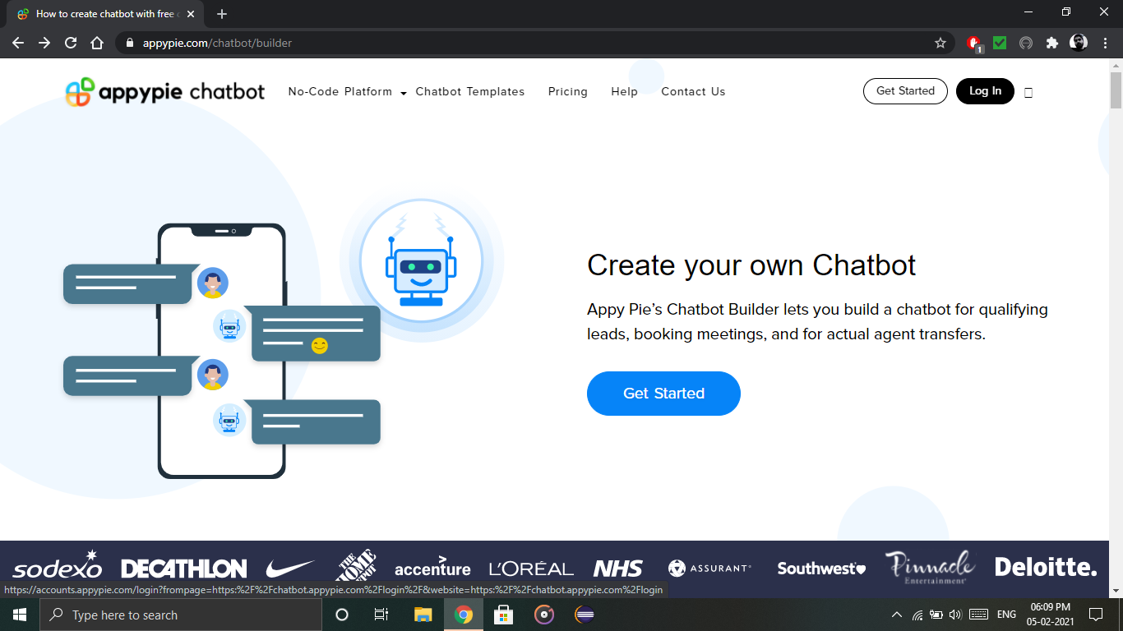

1. Click on “Login with Google” button.

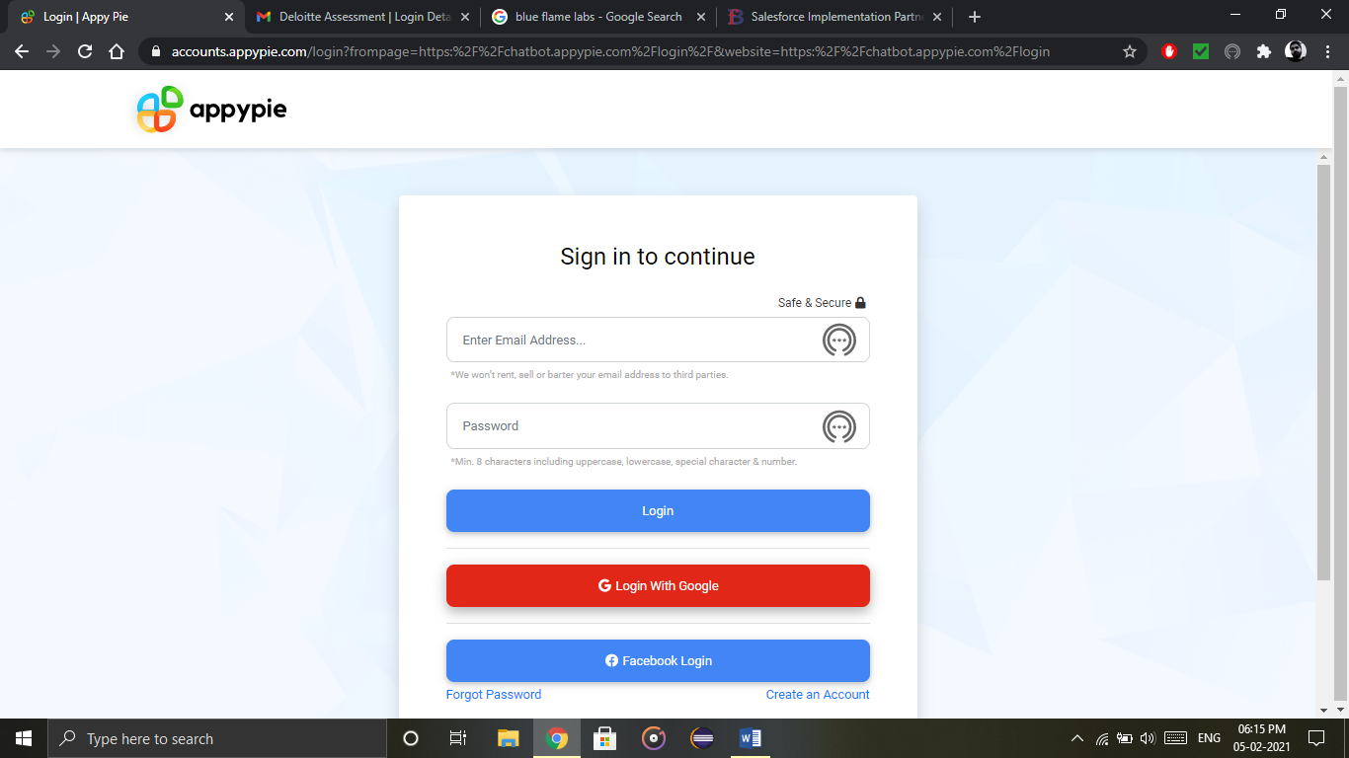

1. Click on the desired account added to your system or else click on Use another account and enter your Gmail credentials to login to appyie chatbot builder to make chatbots.

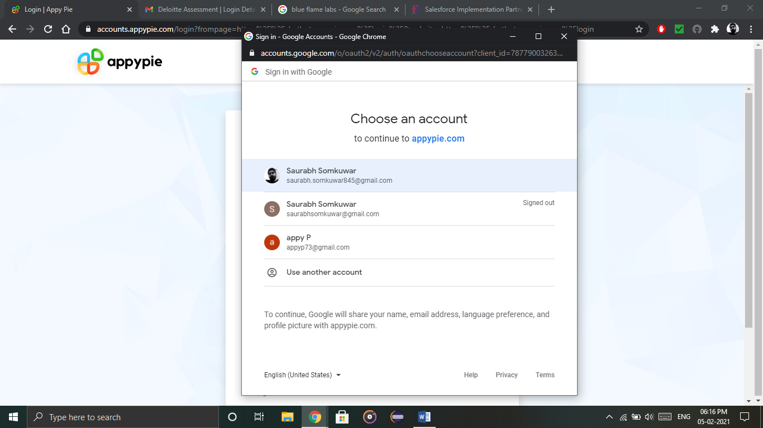

1. Click create bot in the right top corner to start creating bots.

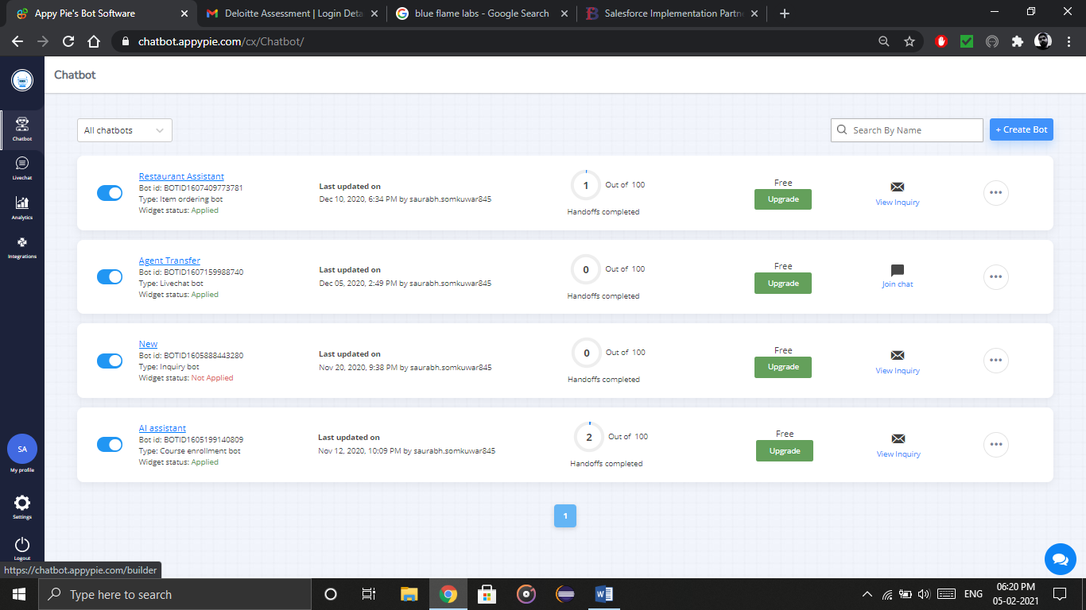

1. Click on logout in the left bottom corner (refer above image, which looks like power button) and you’ll enter the main login screen. Again click on “Login” in the right top and repeat from step 2.

